# Compsoft Technologies



**Providing a Complete Suite of IT Services**

**https://www.compstechnologies.com**

Rajajinagar, Bengaluru, Karnataka, India

AN INTERNSHIP REPORT

ON

“VTU SGPA CALCULATOR”

#### Bachelor of Engineering

#### In

#### Computer Science and Engineering

#### 

#### Submitted by: SANJANA MANJUNATH

#### (1BY18CS140)

#### 

#### 

**BMS INSTITUTE OF TECHNOLOGY**

#### 2022

## ABOUT THE COMPANY

The race for digital transformation is on. In this globally connected on-demand world with rapid advancements in internet technologies, businesses worldwide are under constant pressure to add innovative real-time capabilities to their applications to respond to market opportunities.

​

Every business worldwide is building event-driven, real-time applications - from financial services, transportation, and energy, to retail, healthcare, and Gaming companies.

Our endeavour is to make it easy to develop innovative real-time applications and efficient to operate them in production.

​

We have a proven record of building highly scalable, world-class consulting processes that offer tremendous business advantages to our clients in the form of huge cost-benefits, definitive results and consistent project deliveries across the globe.

​

We prominently strive to improve your business by delivering the full range of competencies including operational performance, developing and applying business strategies to improve financial reports, defining strategic goals and measure and manage those goals along with measuring and managing them.

​

​**Vision**

We are committed to going the extra mile to bring success to the clients consistently  
  
We are dedicated to delivering the right people, solutions, and services to the clients that they require to meet their technology challenges and business goals.

​

​**Mission**

Optimizing client satisfaction with quality services

Delivering the most efficient and the best solution to our clients to every client leveraging leading technologies & industry best practices.

​

**TABLE OF CONTENTS**

Table of contents i

Overview of the Project 4

About VTU SGPA Calculator 5

Tools Used 7

Implementation 8

Snapshots 23

Bibliography 26

## OVERVIEW OF THE PROJECT

## Project Name: VTU SGPA Calculator

**Team Members:** Sanjana Manjunath

Rahul Daruka

Yamini A M

## This project is based on Web Development And its Applications. The main objective of this project is to learn the implementation of HTML, CSS and JavaScript. The basic webpage of this project is created using HTML the styling of the webpage is done using CSS/Bootstrap and the working of the page is coded using JavaScript.

## This webpage consists of a SGPA Calculator which can calculate the GPA of each semester based on the credit system of VTU. User can select the semester, branch and syllabus scheme and enter the marks based on subject code and the SGPA will be calculated for them. This website also includes a GPA to Percentage calculator and also a CGPA calculator based on the all the SGPA scored.

## 

## ABOUT VTU SGPA Calculator

.

SGPA -The performance of a student in a semester is indicated by a number called the **Semester Grade Point Average** (SGPA). The SGPA is the weighted average of the grade points obtained in all the courses, seminars and projects registered by the student during the semester.

A **Grade Point Average** (GPA) is an average of all the grade points you have earned over the course of your degree program. Graduate students are required to have a certain number of a GPA, while sometimes the undergraduates are required to have a smaller number.

This grading system is followed as the standard the understand the overall performance of the students. The students receive the results in the form of marks out of 100 and each subject has a specific value of credit. So, to get the GPA of the semester they have to calculate based on the marks and credits they have got, this may sometimes be confusing for many students to get the correct SGPA that they have scored and to understand the formula. So, to make it easy for the students we have made this SGPA calculator which has preset credits based on the semester, course and the scheme they are studying in, all they have to do is enter the marks that they have scored and the website will calculate the SGPA for the students.

Along with this we have added additional features like CGPA (Cumulative GPA) calculator which the average grade point of all the semesters included and this is the final degree score, so if someone has completed all the semesters, they can calculate the CGPA also. And we have also added a GPA to percentage converter as per VTU formula so that if any student who is asked for their percentage instead of the GPA it becomes easy for them to convert it. This is made for the complete benefit of the students. The UI of the website is designed to be simple and easy to use.

# TOOLS USED

### Software Requirements

* Visual Studio Code 2019.
* Google Chrome or Microsoft Edge of latest version.
* Front End: HTML, CSS, JS (optional)
* Linux 7.1 or Windows XP/7/8/10 OS or Mac OS

### Hardware Requirements

* Pentium 200-MHz computer with a minimum of 64 MB of RAM (128 MB of RAM recommended).
* Monitor with a refresh rate of at least 40Hz for a smooth GUI experience (optional).

# IMPLEMENTATION

# Source Code (P2.HTML):

<!DOCTYPE HTML>

<html lang="en">

<head>

    <title>VTU ABACUS | BetaBots</title>

    <meta name="viewport" content="width=device-width, initial-scale=1">

    <meta charset="utf-8">

    <meta name="keywords" content="sgpa Calculator, Calculator, cgpa Calculator, VTU, cbcs,non cbcs" />

    <script>

        addEventListener("load", function () {

            setTimeout(hideURLbar, 0);

        }, false);

        function hideURLbar() {

            window.scrollTo(0, 1);

        }

    </script>

    <!-- Bootstrap Core CSS -->

    <link href="static/css/bootstrap.css" rel='stylesheet' type='text/css' />

    <!-- Custom CSS -->

    <link href="static/css/style.css" rel='stylesheet' type='text/css' />

     <!-- font-awesome icons -->

    <link  href="static/css/fontawesome-all.min.css" rel="stylesheet">

    <!-- pop up box -->

    <link href="static/css/popup-box.css" rel="stylesheet" type="text/css" media="all" />

    <link rel="stylesheet" href="static/css/owl.carousel.css" type="text/css" media="all">

    <link rel="stylesheet" href="static/css/owl.theme.css" type="text/css" media="all">

</head>

<body>

    <!-- header -->

    <header>

        <div class="header-bottom">

            <div class="container">

                <nav class="navbar navbar-expand-lg navbar-dark p-0">

                    <h1><a class="navbar-brand" href="index.html">

                           VTU Abacus

                        </a></h1>

                    <button class="navbar-toggler ml-lg-auto ml-sm-5" type="button" data-toggle="collapse" data-target="#navbarSupportedContent"

                        aria-controls="navbarSupportedContent" aria-expanded="false" aria-label="Toggle navigation">

                        <span class="navbar-toggler-icon"></span>

                    </button>

                    <div class="collapse navbar-collapse" id="navbarSupportedContent">

                        <ul class="navbar-nav text-center ml-auto">

                            <li class="nav-item  mr-lg-3 mt-lg-0 mt-4">

                              <a class="hover-fill" aria-pressed="false" href="sgpa.html" data-txthover="PERCENTAGE CALCULATOR">PERCENTAGE CALCULATOR</a>

                            </li>

                            <li class="nav-item  mr-lg-3 mt-lg-0 mt-4">

                                <a class="hover-fill" aria-pressed="false" href="index.html" data-txthover="SGPA CALCULATOR">SGPA CALCULATOR</a>

                            </li>

                            <li class="nav-item">

                                <a class="hover-fill" aria-pressed="false" href="cgpa.html" data-txthover="CGPA CALCULATOR">CGPA CALCULATOR</a>

                            </li>

                        </ul>

                    </div>

                </nav>

            </div>

        </div>

    </header>

    <!-- //header -->

    <!-- banner -->

    <div class="screenview_bg bg-theme">

        <div class="container">

          <section class="wthree-row w3-gallery py-5">

                <div class="container py-xl-5">

                    <div class="w3l_header mb-sm-5 pb-3">

                <h3 class="text-center">VTU SGPA Calculator</h3>

                    </div>

            </div>

            <div class="row">

              <div class="col">

                <div class="container">

                <div class="login mb-sm-5 px-4 mx-auto mw-100">

                <form id="choose" action="#" method="post">

                    <fieldset>

                      <legend>Choose accordingly</legend>

                      <div class="form-row">

                        <div class="form-group col-md-6 mb-4">

                            <label class="col-form-label">Sem</label>

                        </div>

                        <div class="col-md-6 mb-4">

                          <select class="form-control" id="sem">

                            <option value="1st_sem">1st sem</option>

                            <option value="2nd_sem">2nd sem</option>

                            <option value="3rd_sem">3rd sem</option>

                            <option value="4th_sem">4th sem</option>

                            <option value="5th_sem">5th sem</option>

                            <option value="6th_sem">6th sem</option>

                            <option value="7th_sem">7th sem</option>

                            <option value="8th_sem">8th sem</option>

                          </select>

                        </div>

                      </div>

                      <div class="form-row">

                        <div class="form-group col-md-6 mb-4">

                            <label class="col-form-label">Branch</label>

                        </div>

                        <div class="col-md-6 mb-4">

                          <select class="form-control" id="branch">

                            <option value="1" >B.E-AERONAUTICAL ENGINEERING</option>

                            <option value="2" >B.E-AUTOMOBILE ENGINEERING</option>

                            <option value="3" >B.E-BIO-MEDICAL ENGINEERING</option>

                            <option value="4" >B.E-BIOTECHNOLOGY</option>

                            <option value="5" >B.E-CERAMICS & CEMENT TECHNOLOGY</option>

                            <option value="6" >B.E-CHEMICAL ENGINEERING</option>

                            <option value="7" >B.E-CIVIL ENGINEERING</option>

                            <option value="8" >B.E-COMPUTER SCIENCE & ENGINEERING</option>

                            <option value="9" >B.E-CONSTRUCTION TECHNOLOGY AND MANAGEMENT</option>

                            <option value="10">B.E-PRECISION MANUFACTURING</option>

                            <option value="11">B.E-ELECTRICAL & ELECTRONICS ENGINEERING</option>

                            <option value="12">B.E-ELECTRONICS & COMMUNICATION ENGINEERING</option>

                            <option value="13">B.E-ENVIRONMENTAL ENGINEERING</option>

                            <option value="14">B.E-INDUSTRIAL & PRODUCTION ENGINEERING</option>

                            <option value="15">B.E-INDUSTRIAL ENGINEERING & MANAGEMENT</option>

                            <option value="16">B.E-INFORMATION SCIENCE & ENGINEERING</option>

                            <option value="17">B.E-INSTRUMENTATION TECHNOLOGY</option>

                            <option value="18">B.E-MANUFACTURING SCIENCE & ENGINEERING</option>

                            <option value="19">B.E-MECHANICAL ENGINEERING</option>

                            <option value="20">B.E-MECHATRONICS ENGINEERING</option>

                            <option value="21">B.E-MEDICAL ELECTRONICS</option>

                            <option value="22">B.E-MINING ENGINEERING</option>

                            <option value="23">B.E-POLYMER SCIENCE & TECHNOLOGY</option>

                            <option value="24">B.E-PRINTING TECHNOLOGY</option>

                            <option value="25">B.E-SILK TECHNOLOGY</option>

                            <option value="26">B.E-TELECOMMUNICATION ENGINEERING</option>

                            <option value="27">B.E-TEXTILE TECHNOLOGY</option>

                            <option value="28">B.E-TRANSPORTATION ENGINEERING</option>

                            <option value="29">B.E-TOOL ENGINEERING</option>

                          </select>

                        </div>

                      </div>

                      <div class="form-row">

                        <div class="form-group col-md-6 mb-4">

                            <label class="col-form-label">Scheme</label>

                        </div>

                        <div class="col-md-6 mb-4">

                          <select class="form-control" id="scheme">

                            <option value="2018_scheme">2018</option>

                            <option value="2017_scheme">2017</option>

                          </select>

                        </div>

                      </div>

                    </fieldset>

                    <br>

                    <div class='text-center' style="margin-top: 10px">

                        <button type="submit" class="">Submit</button>

                    </div>

                </form>

          </section>

        </div>

    </div>

    <!-- //banner -->

    <!-- //footer -->

    <div class="cpy-right">

        <p class="text-white">© <script>document.write(new Date().getFullYear())</script> Design by

            BetaBots

        </p>

    </div>

    <!-- js -->

    <script src="static/js/jquery-2.2.3.min.js"></script>

    <!--pop-up-box -->

    <script src="static/js/jquery.magnific-popup.js"></script>

  <script type="text/javascript">

    document.getElementById('choose').onsubmit = function() {

        if (document.getElementById('sem').value=="7th_sem" && document.getElementById('scheme').value=="2018_scheme" && document.getElementById('branch').value == 8) {

            window.location.replace("calc/"+document.getElementById('scheme').value+'-'+document.getElementById('sem').value+'s.html');

            return false;

        }

        window.location.replace("calc/"+document.getElementById('scheme').value+'-'+document.getElementById('sem').value+'.html?br='+document.getElementById('branch').value);

        return false;

    };

  </script>

    <script src="static/js/SmoothScroll.min.js"></script>

    <script src="static/js/bootstrap.js"></script>

</body>

</html>

# Implementation of HTML for one of the semesters.

<!DOCTYPE HTML>

<html lang="en">

<head>

    <title>VTU ABACUS | BetaBots</title>

    <meta name="viewport" content="width=device-width, initial-scale=1">

    <meta charset="utf-8">

    <meta name="keywords" content="sgpa Calculator, Calculator, cgpa Calculator, VTU, cbcs,non cbcs" />

    <script>

        addEventListener("load", function () {

            setTimeout(hideURLbar, 0);

        }, false);

        function hideURLbar() {

            window.scrollTo(0, 1);

        }

    </script>

    <!-- Bootstrap Core CSS -->

    <link href="../static/css/bootstrap.css" rel='stylesheet' type='text/css' />

    <!-- Custom CSS -->

    <link href="../static/css/style.css" rel='stylesheet' type='text/css' />

     <!-- font-awesome icons -->

    <link  href="../static/css/fontawesome-all.min.css" rel="stylesheet">

  <!-- pop up box -->

  <link href="../static/css/popup-box.css" rel="stylesheet" type="text/css" media="all" />

  <link rel="stylesheet" href="../static/css/owl.carousel.css" type="text/css" media="all">

  <link rel="stylesheet" href="../static/css/owl.theme.css" type="text/css" media="all">

</head>

<body>

    <!-- header -->

    <header>

        <div class="header-bottom">

            <div class="container">

                <nav class="navbar navbar-expand-lg navbar-dark p-0">

                    <h1><a class="navbar-brand" href="../index.html">

                           VTU Abacus

                        </a>

                    </h1>

                <button class="navbar-toggler ml-lg-auto ml-sm-5" type="button" data-toggle="collapse" data-target="#navbarSupportedContent"

                    aria-controls="navbarSupportedContent" aria-expanded="false" aria-label="Toggle navigation">

                    <span class="navbar-toggler-icon"></span>

                </button>

                <div class="collapse navbar-collapse" id="navbarSupportedContent">

                    <ul class="navbar-nav text-center ml-auto">

                      <li class="nav-item  mr-lg-3 mt-lg-0 mt-4">

                        <a class="hover-fill" aria-pressed="false" href="../sgpa.html" data-txthover="PERCENTAGE CALCULATOR">PERCENTAGE CALCULATOR</a>

                      </li>

                      <li class="nav-item  mr-lg-3 mt-lg-0 mt-4">

                          <a class="hover-fill" aria-pressed="false" href="../index.html" data-txthover="SGPA CALCULATOR">SGPA CALCULATOR</a>

                      </li>

                      <li class="nav-item">

                          <a class="hover-fill" aria-pressed="false" href="../cgpa.html" data-txthover="CGPA CALCULATOR">CGPA CALCULATOR</a>

                      </li>

                    </ul>

                </nav>

            </div>

        </div>

    </header>

    <div class="screenview_bg bg-theme px-3">

    <div class="container">

          <section class="wthree-row w3-gallery py-5">

            <div class="container py-xl-5">

              <div class="w3l_header mb-sm-5 pb-3">

                <h3 class="text-center">1st SEM SGPA</h3>

              </div>

            </div>

                <!-- //gallery container -->

                    <div class="container">

                    <div class="login mb-sm-5 px-4 mx-auto mw-100">

                    <form id="1stsem" action="#" method="post">

                      <div class="row">

                      <div class="col-5">

                        <fieldset>

                            <div class="form-row">

                              <div class="form-group col-md-6 mb-4">

                                  <label class="col-form-label">18MAT11</label>

                              </div>

                              <div class="col-md-6 mb-4">

                                <input type="text" class="form-control" id="18MAT11" name="18MAT11" placeholder="18MAT11" required>

                              </div>

                            </div>

                            <div class="form-row">

                              <div class="form-group col-md-6 mb-4">

                                  <label class="col-form-label">18XXX12</label>

                              </div>

                              <div class="col-md-6 mb-4">

                                <input type="text" class="form-control" id="18XXX12" name="18XXX12" placeholder="18XXX12" required>

                              </div>

                            </div>

                            <div class="form-row">

                              <div class="form-group col-md-6 mb-4">

                                  <label class="col-form-label">18XXX13</label>

                              </div>

                              <div class="col-md-6 mb-4">

                                <input type="text" class="form-control" id="18XXX13" name="18XXX13" placeholder="18XXX13" required>

                              </div>

                            </div>

                            <div class="form-row">

                              <div class="form-group col-md-6 mb-4">

                                  <label class="col-form-label">18XXX14</label>

                              </div>

                              <div class="col-md-6 mb-4">

                                <input type="text" class="form-control" id="18XXX14" name="18XXX14" placeholder="18XXX14" required>

                              </div>

                            </div>

                      </fieldset>

                    </div>

                    <div class="col-2">

                    </div>

                    <div class="col-5">

                      <fieldset>

                            <div class="form-row">

                              <div class="form-group col-md-6 mb-4">

                                  <label class="col-form-label">18XXX15</label>

                              </div>

                              <div class="col-md-6 mb-4">

                                <input type="text" class="form-control" id="18XXX15" name="18XXX15" placeholder="18XXX15" required>

                              </div>

                            </div>

                            <div class="form-row">

                              <div class="form-group col-md-6 mb-4">

                                  <label class="col-form-label">18XXL16</label>

                              </div>

                              <div class="col-md-6 mb-4">

                                <input type="text" class="form-control" id="18XXL16" name="18XXL16" placeholder="18XXL16" required>

                              </div>

                            </div>

                            <div class="form-row">

                              <div class="form-group col-md-6 mb-4">

                                  <label class="col-form-label">18XXL17</label>

                              </div>

                              <div class="col-md-6 mb-4">

                                <input type="text" class="form-control" id="18XXL17" name="18XXL17" placeholder="18XXL17" required>

                              </div>

                            </div>

                            <div class="form-row">

                              <div class="form-group col-md-6 mb-4">

                                  <label class="col-form-label">18XXX18</label>

                              </div>

                              <div class="col-md-6 mb-4">

                                <input type="text" class="form-control" id="18XXX18" name="18XXX18" placeholder="18XXX18" required>

                              </div>

                            </div>

                        </fieldset>

                        <br>

                      </div>

                      </div>

                        <div class='text-center' style="margin-top: 10px">

                            <button type="submit" class="">Calculate SGPA</button>

                        </div>

                    </form>

                    </div>

                  </div>

                  <div class="row">

                  <div class="col">

                    <fieldset disabled>

                      <div class="container" style="margin:0 auto; width: 50%;">

                        <legend>Result</legend>

                          <div class="form-row">

                            <div class="form-group col-md-6 mb-4">

                                <label class="col-form-label">SGPA</label>

                            </div>

                            <div class="col-md-6 mb-4">

                              <input type="text" id="sgpa" class="form-control" placeholder="SGPA">

                            </div>

                          </div>

                          <div class="form-row">

                              <div class="form-group col-md-6 mb-4">

                                  <label class="col-form-label">Percentage</label>

                              </div>

                              <div class="col-md-6 mb-4">

                                  <input type="text" id="percentage" class="form-control" placeholder="Percentage">

                              </div>

                          </div>

                        </div>

                    </fieldset>

                  </div>

                </div>

            </section>

    </div>

    </div>

    <div class="cpy-right">

        <p class="text-white">© <script>document.write(new Date().getFullYear())</script> Design by

            BetaBots

        </p>

    </div>

</body>

</html>

# IMPLEMENTATION

# Source Code (P2.CSS+P2.JS):

# CSS

* {box-sizing:border-box}

/* Slideshow container */

.slideshow-container {

  max-width: 1000px;

  position: relative;

  margin: auto;

}

/* Hide the images by default */

.mySlides {

  display: none;

}

/* Next & previous buttons */

.prev, .next {

  cursor: pointer;

  position: absolute;

  top: 50%;

  width: auto;

  margin-top: -22px;

  padding: 16px;

  color: white;

  font-weight: bold;

  font-size: 18px;

  transition: 0.6s ease;

  border-radius: 0 3px 3px 0;

  user-select: none;

}

/* Position the "next button" to the right */

.next {

  right: 0;

  border-radius: 3px 0 0 3px;

}

/* On hover, add a black background color with a little bit see-through */

.prev:hover, .next:hover {

  background-color: rgba(0,0,0,0.8);

}

/* Caption text */

.text {

  color: #f2f2f2;

  font-size: 15px;

  padding: 8px 12px;

  position: absolute;

  bottom: 8px;

  width: 100%;

  text-align: center;

}

/* Number text (1/3 etc) */

.numbertext {

  color: #f2f2f2;

  font-size: 12px;

  padding: 8px 12px;

  position: absolute;

  top: 0;

}

/* The dots/bullets/indicators */

.dot {

  cursor: pointer;

  height: 15px;

  width: 15px;

  margin: 0 2px;

  background-color: #bbb;

  border-radius: 50%;

  display: inline-block;

  transition: background-color 0.6s ease;

}

.active, .dot:hover {

  background-color: #717171;

}

/* Fading animation */

.fade {

  -webkit-animation-name: fade;

  -webkit-animation-duration: 1.5s;

  animation-name: fade;

  animation-duration: 1.5s;

}

@-webkit-keyframes fade {

  from {opacity: .4}

  to {opacity: 1}

}

@keyframes fade {

  from {opacity: .4}

  to {opacity: 1}

}

**JavaScript**

<script type="text/javascript">

    document.getElementById('choose').onsubmit = function() {

        if (document.getElementById('sem').value=="7th_sem" && document.getElementById('scheme').value=="2018_scheme" && document.getElementById('branch').value == 8) {

            window.location.replace("calc/"+document.getElementById('scheme').value+'-'+document.getElementById('sem').value+'s.html');

            return false;

        }

        window.location.replace("calc/"+document.getElementById('scheme').value+'-'+document.getElementById('sem').value+'.html?br='+document.getElementById('branch').value);

        return false;

    }; <script type="text/javascript">

    document.getElementById('cgpac').onsubmit = function() {

        var tc=175;

        var sum=0;

        var cgpa;

        const credits = [20,20,24,24,25,24,20,18]

        const sem = ["1stSem", "2ndSem", "3rdSem", "4thSem", "5thSem", "6thSem", "7thSem", "8thSem"];

        sem.forEach(myFunction);

        function myFunction(value, index, array) {

          var g = document.getElementById(value).value;

          if (g ==0){

            tc = tc-credits[index];

          }

          else{

            sum+= g*credits[index];

          }

        }

        cgpa = sum/tc;

        document.getElementById('cgpa').value = cgpa.toFixed(2);

        percentage = (cgpa-0.75)*10;

        document.getElementById('percentage').value = percentage.toFixed(2);

        return false;

    };

  </script>

<script type="text/javascript">

    document.getElementById('1stsem').onsubmit = function() {

        const urlParams = new URLSearchParams(window.location.search);

        const branch = urlParams.get('br');

        var i = 0;

        if (branch==1){

          i=1;

        }

        else if (branch==2) {

          i=2;

        }

        const tc=20;

        var sum=0;

        var sqpa;

        const credits = [4,4,3,3,3,1,1,1];

        const sub = ["18MAT11", "18XXX12", "18XXX13", "18XXX14", "18XXX15", "18XXL16", "18XXL17", "18XXX18"];

        sub.forEach(myFunction);

        function myFunction(value, index, array) {

          var g = document.getElementById(value).value;

          if (g >=90){

            sum+=10*credits[index];

          }

          else if (g >=80){

            sum+=9*credits[index];

          }

          else if (g >=70){

            sum+=8*credits[index];

          }

          else if (g >=60){

            sum+=7*credits[index];

          }

          else if (g >=45){

            sum+=6*credits[index];

          }

          else if (g >=40){

            sum+=4*credits[index];

          }

          else{

            sum+=0;

          }

        }

        sgpa = sum/tc;

        document.getElementById('sgpa').value = sgpa.toFixed(2);

        percentage = (sgpa-0.75)*10;

        document.getElementById('percentage').value = percentage.toFixed(2);

        return false;

    };

  </script>

<script type="text/javascript">

    document.getElementById('cgpac').onsubmit = function() {

        var percentage;

        var g = document.getElementById('gpa').value;

        percentage = (g-0.75)*10;

        document.getElementById('percentage').value = percentage.toFixed(2);

        return false;

    };

# IMPLEMENTATION

# Snapshots:

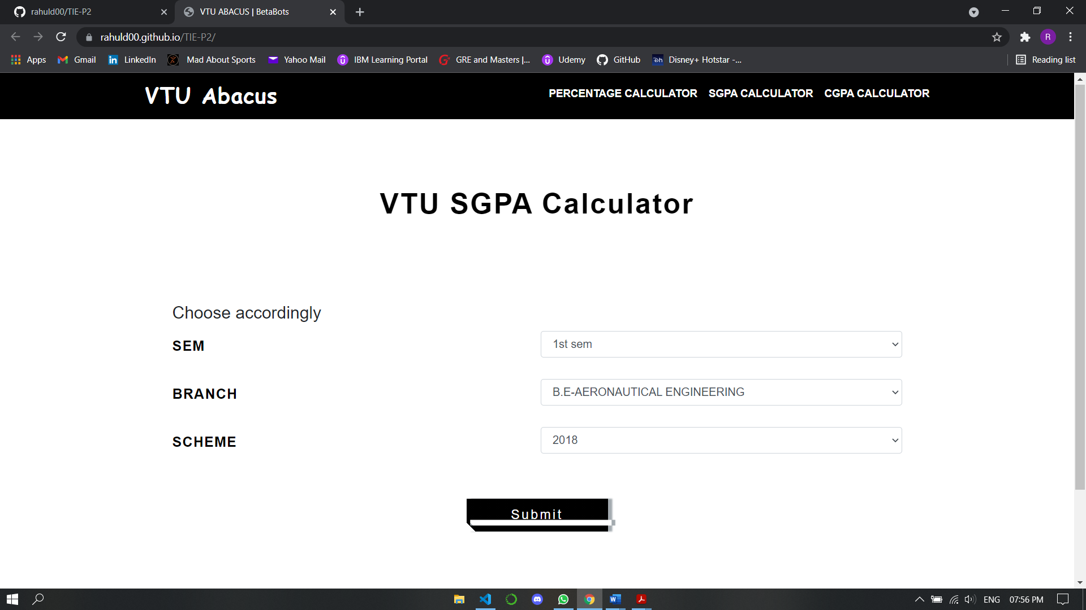

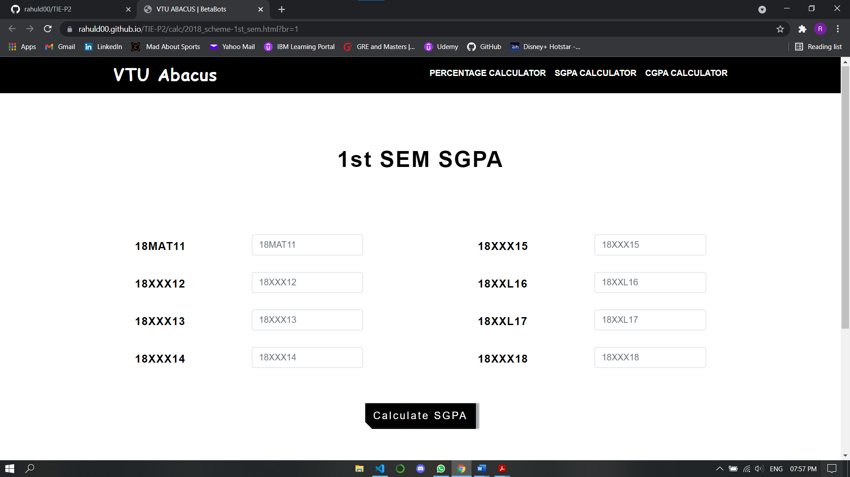

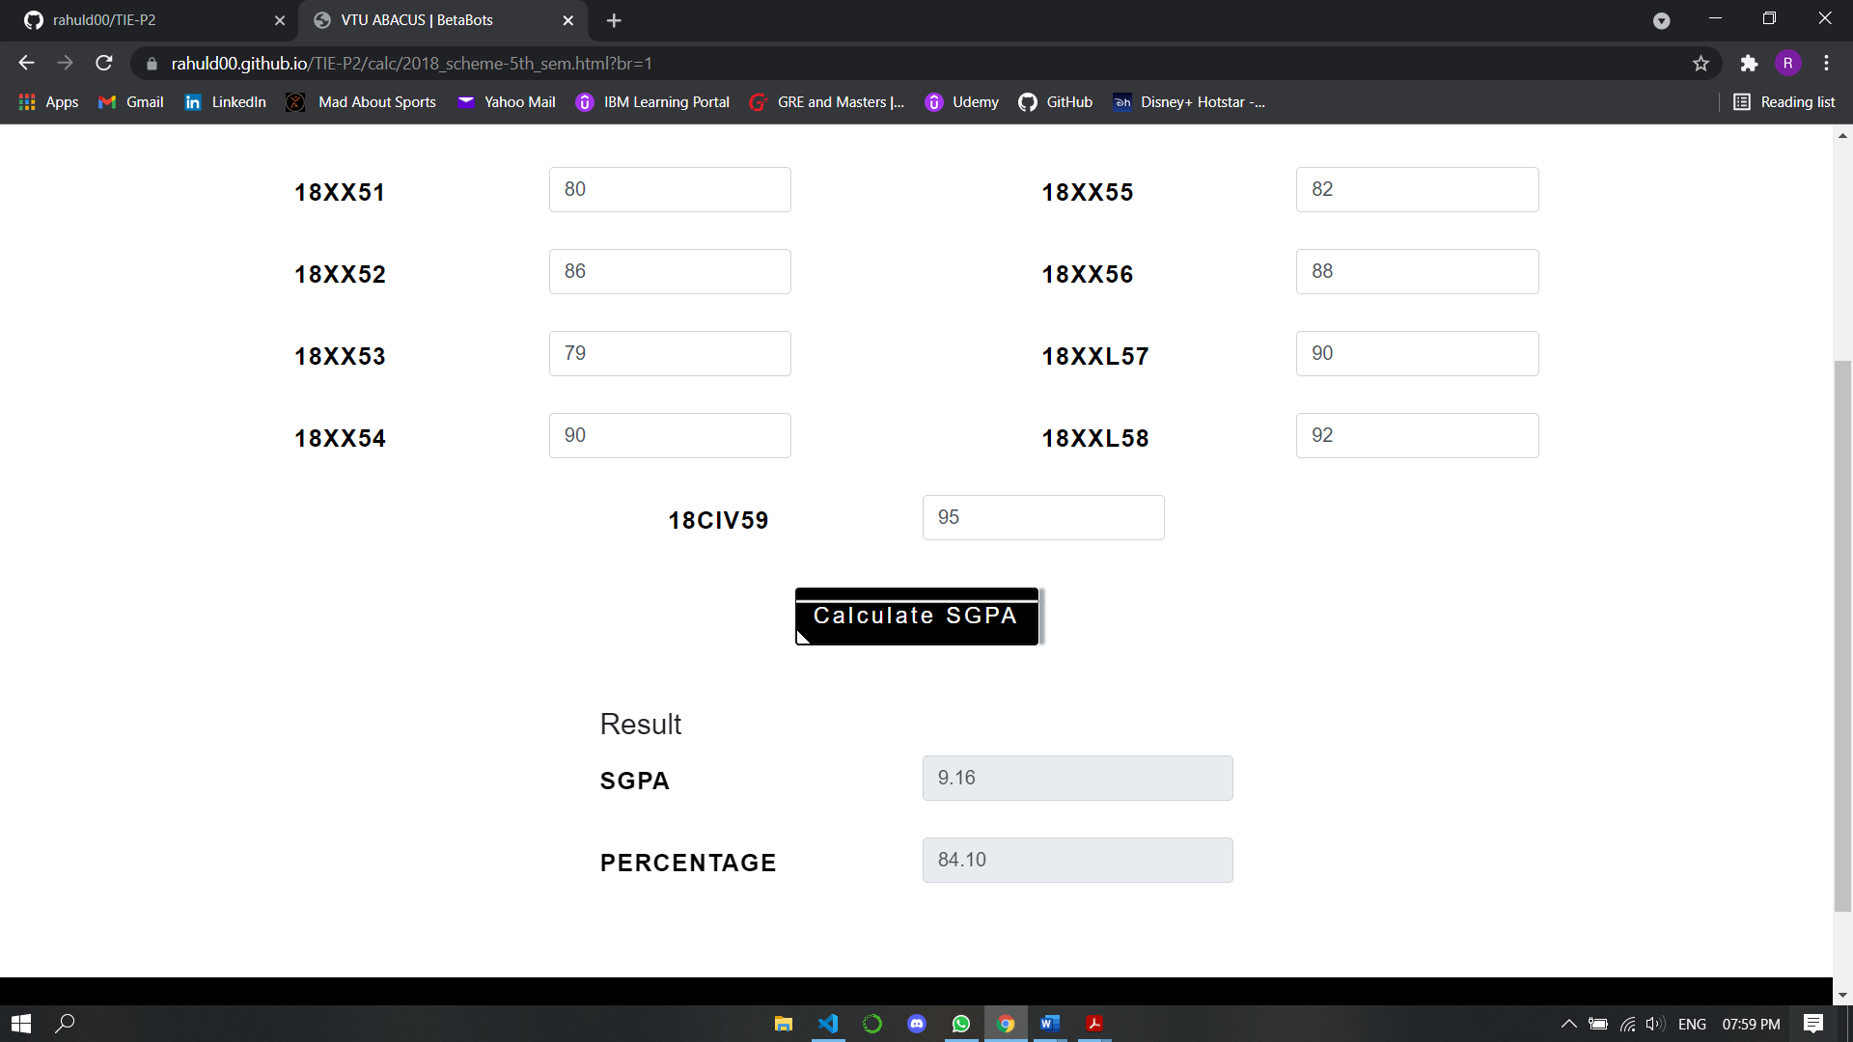

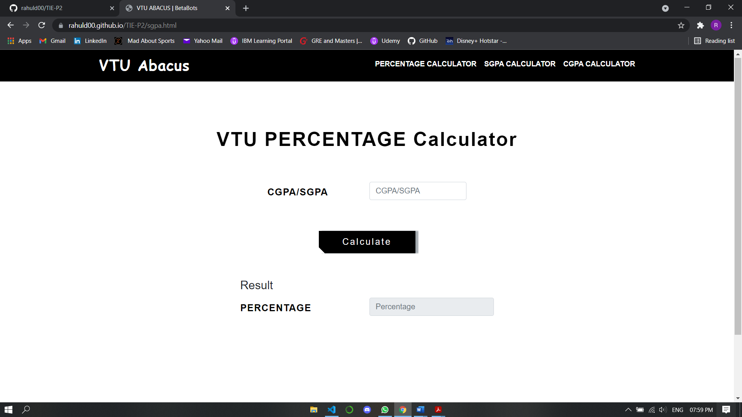

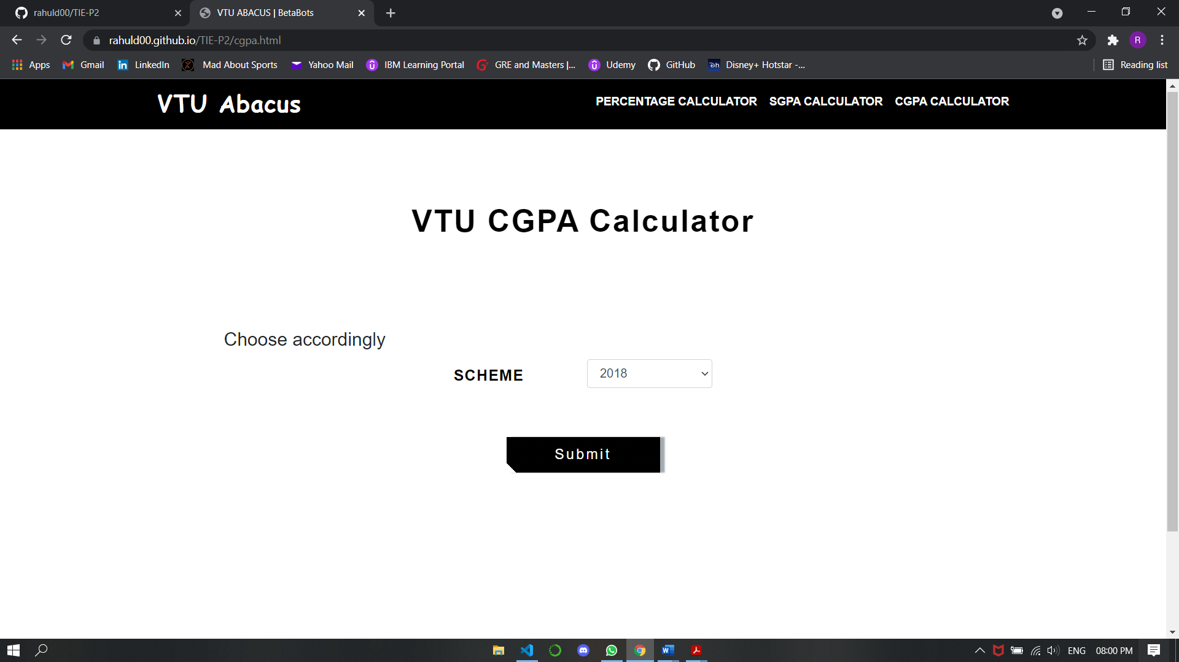

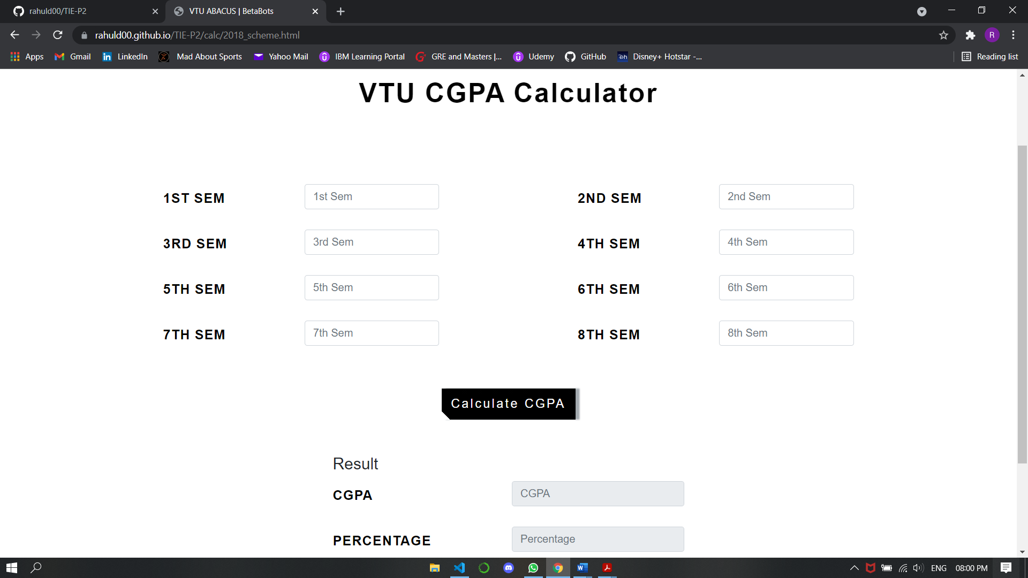

**BIBLIOGRAPHY**

* [www.w3schools.com](http://www.w3schools.com)
* [www.geeksforgeeks.org](http://www.geeksforgeeks.org)
* <https://freefrontend.com>
* <https://vtu.ac.in/>
* <https://www.vturesource.com/>
* <https://developer.mozilla.org/en-US/docs/Web/CSS>
* <https://www.w3schools.com/js/DEFAULT.asp>

## About my TEAM

**Sanjana Manjunath** - Worked on the graphics and design and layout of the webpage.

**Rahul Daruka** - Worked on the complete building of website from the scratch using HTML, CSS and JavaScript.

**Yamini A M** - Worked on the complete information and information required for the webpage.